RESUME
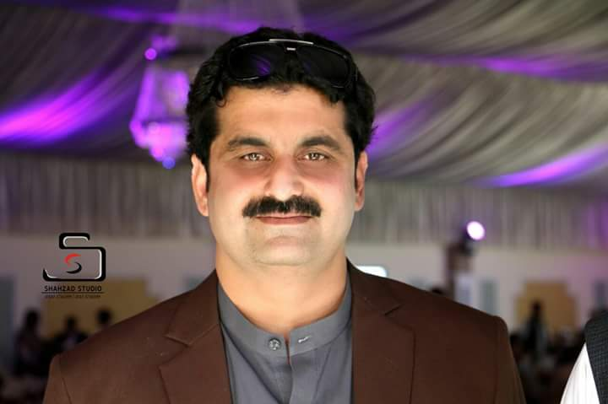

Abuzar Khan
Department of Pharmacy University of Peshawar. Khyberpukhtoon khwa Pakistan | Res:-+92-91-6610936  Off: +92-91-59216750 Ext 144  Cell:-+92-333-9228402  E-mail:-akpharm@upesh.edu.pk

Objective | To work for a progressive organization offering opportunities for growth and reward.
Experience | Lecturer Clinical Pharmacy Deptt Of Pharmacy Univerity of Peshawar. KPK Pakistan  From: Sept. 2008 till Now Sept. 2014  - Lecturer Clinical Pharmacy.  - Supervisor Clinical Clerkship Hayatabad Medical Complex  - Ph.D Scholar Psychiatry Ward Khyber Teaching Hospital KPK Pakistan.  Khyber Teaching Hospital Peshawar Psychiatry Ward as a National Intern :  From: - Sep 2007 till 31 august 2008.  Hospital pharmacist:  Main responsibilities included:-  - Checking the daily drug expenses in wards.  - Recording the adverse drug reaction.  - Pharmaco economic Study.  - Endowment fund Pharmacy stock maintenance.  - Schizophrenia management.  Clinical clerkship in Psychiatry ward at KTH:  From:-April 2007 to July 2007.  Clinical pharmacist:  Main responsibilities included:-  - Study Patient Medication profile for ADRS.  - Dose adjustment.  - Drug drug interactions.  - Compliance non compliance of patients.  - Priority drug use in the ward.  - To study the side effects of drugs in Patients.
Education | - 2008 Department of Pharmacy University of Peshawar.  - Pharm D (1st Div, 75% Marks)
Personal Details | Birth date: 15-09-1983  Marital Status: Single  Domicile: Charsadda (N.W.F.P.) Pakistan  NIC: : 17101-9791418-9  Languages: English, Urdu, and Pushto.
References | Prof.Dr. Fazal Subhan Bpham, M.Pharm, PhD (UK)  Prof.Dr. Zafar Iqbal B pharm, PhD (Uk), Post Doc (UK)

